Today everyone need legal services for some or the other reason. It is very difficult to find lawyers with respective specialization. Getting appointment is also very difficult. There is a need to have a website for doing all this.

We need to design and develop a website for lawyers and their service. Customers can register and search for lawyers basing their requirement. Info related to lawyers will be there in website which customers can browse through and view their profile before contacting them.

Customers can book a schedule for meeting with lawyer. We also had a discussion in regard to few clarifications and inputs specifically to understand the project flow.

JUST LAW

Home

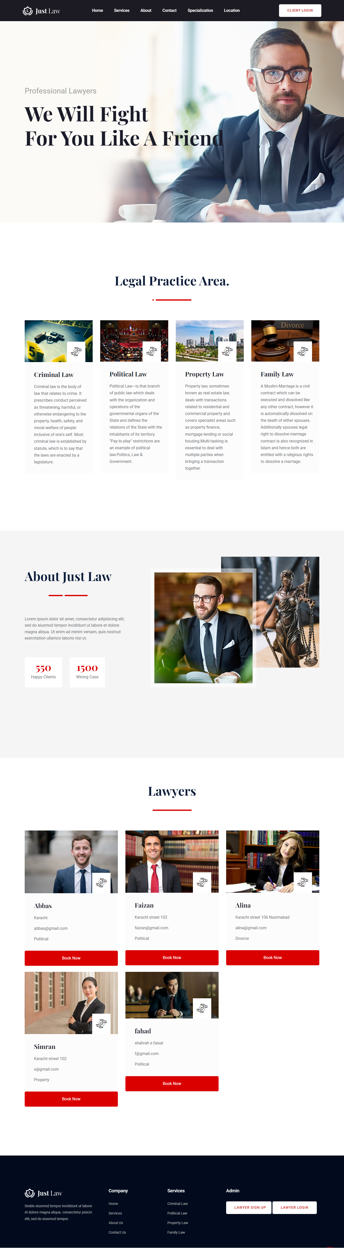

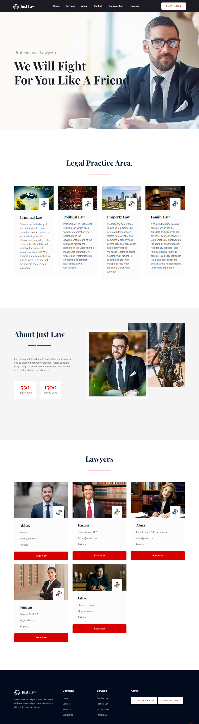

Services

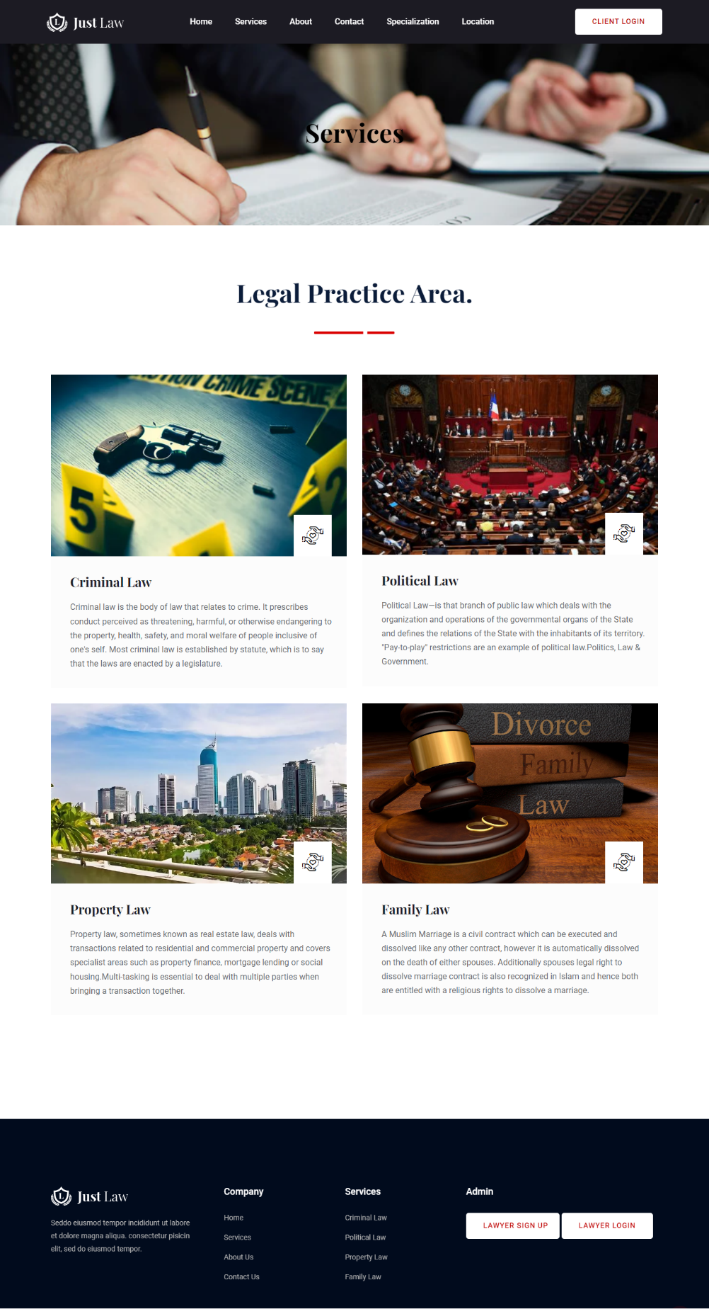

About

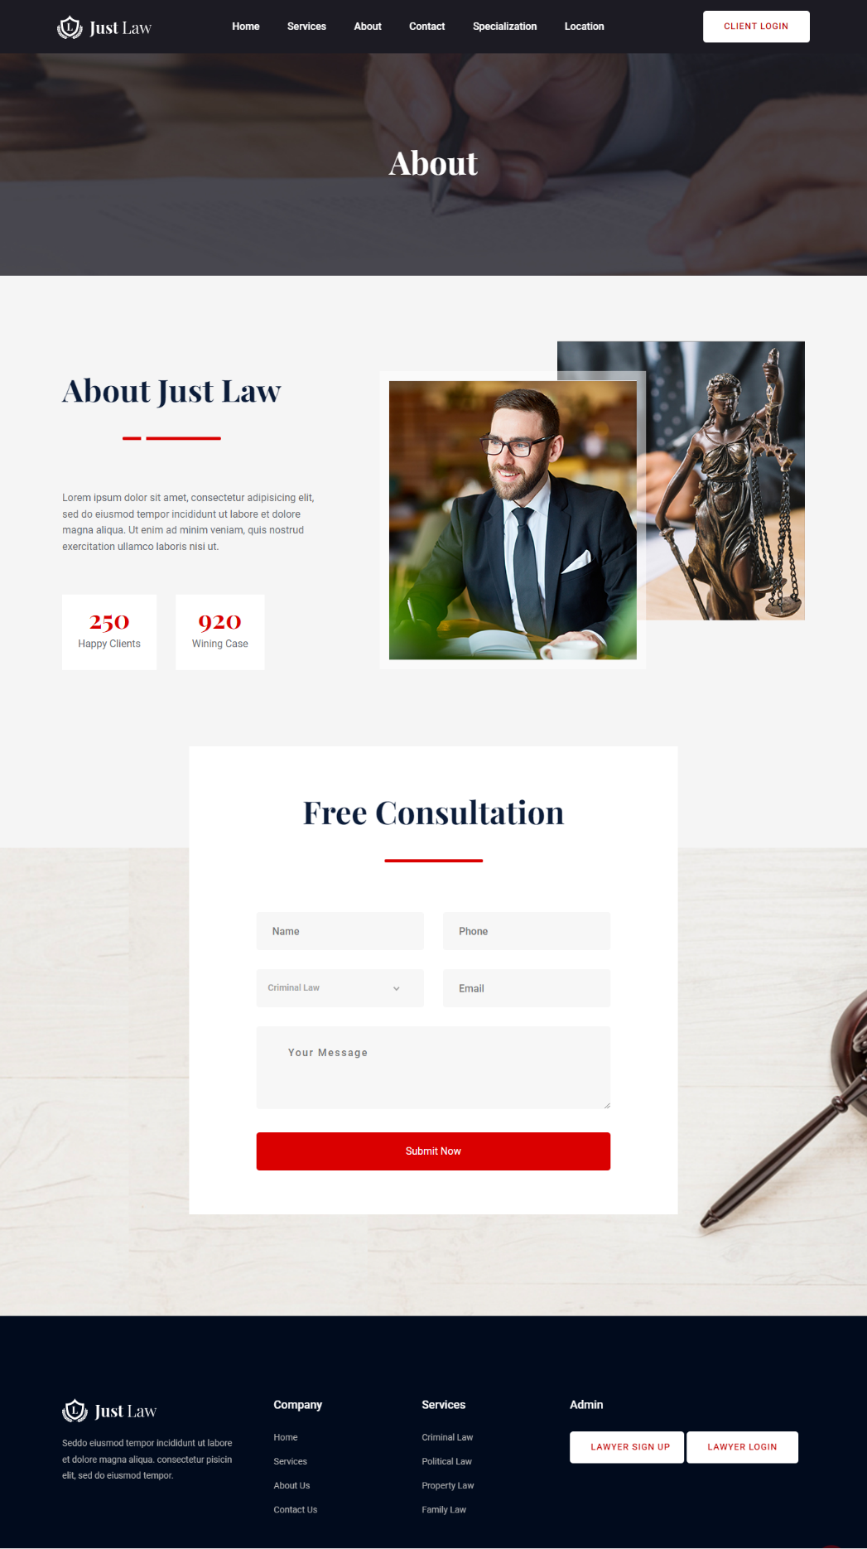

Contact

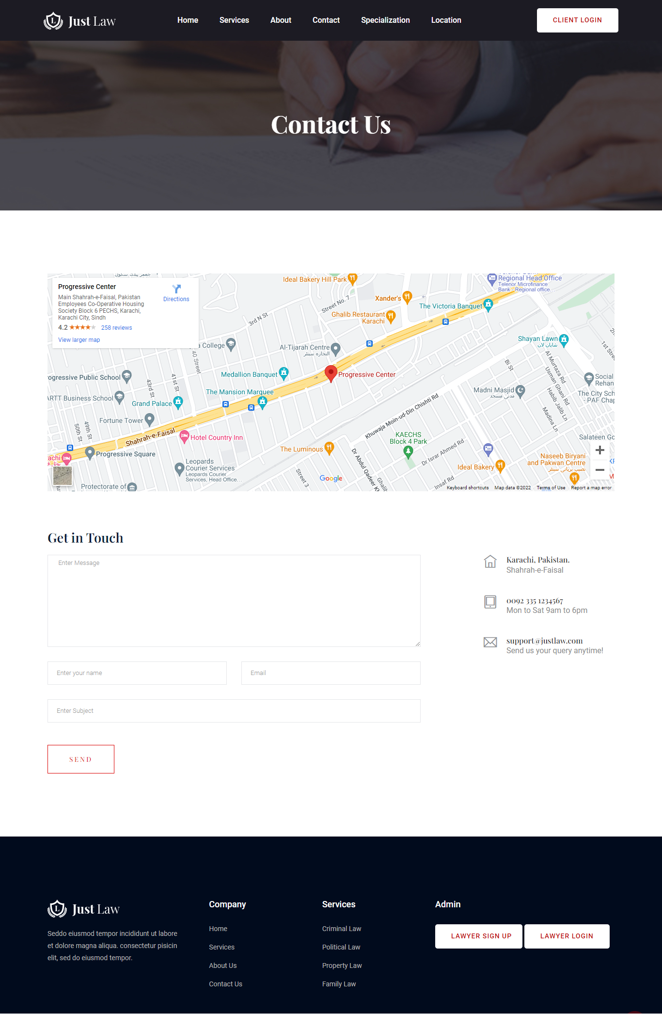

Customer Sign Up

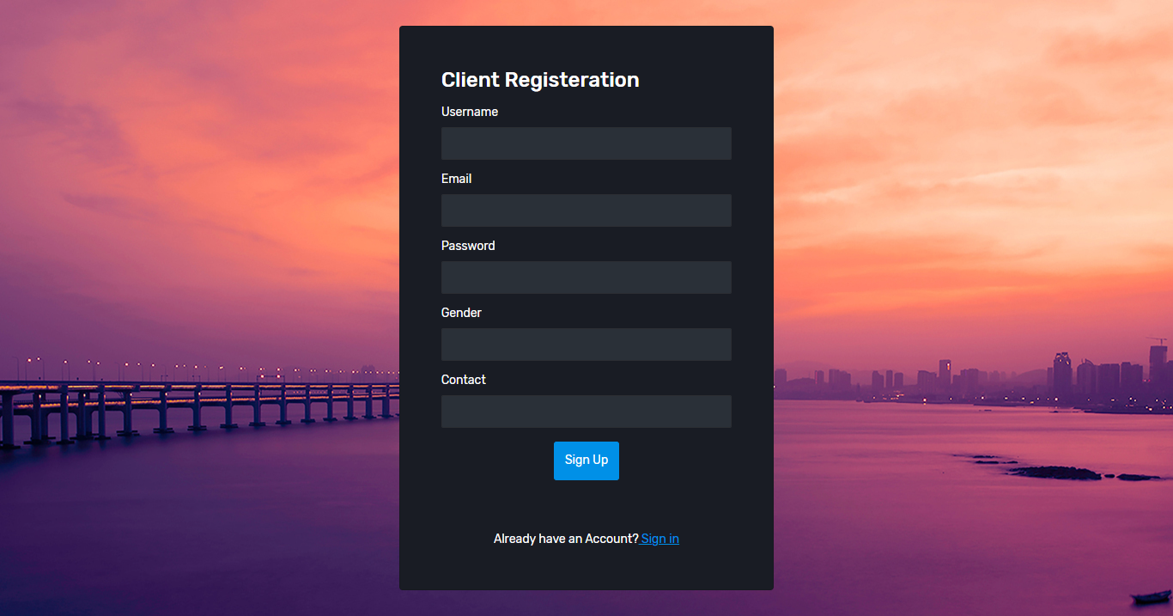

Customer Sign In



Lawyer Sign Up

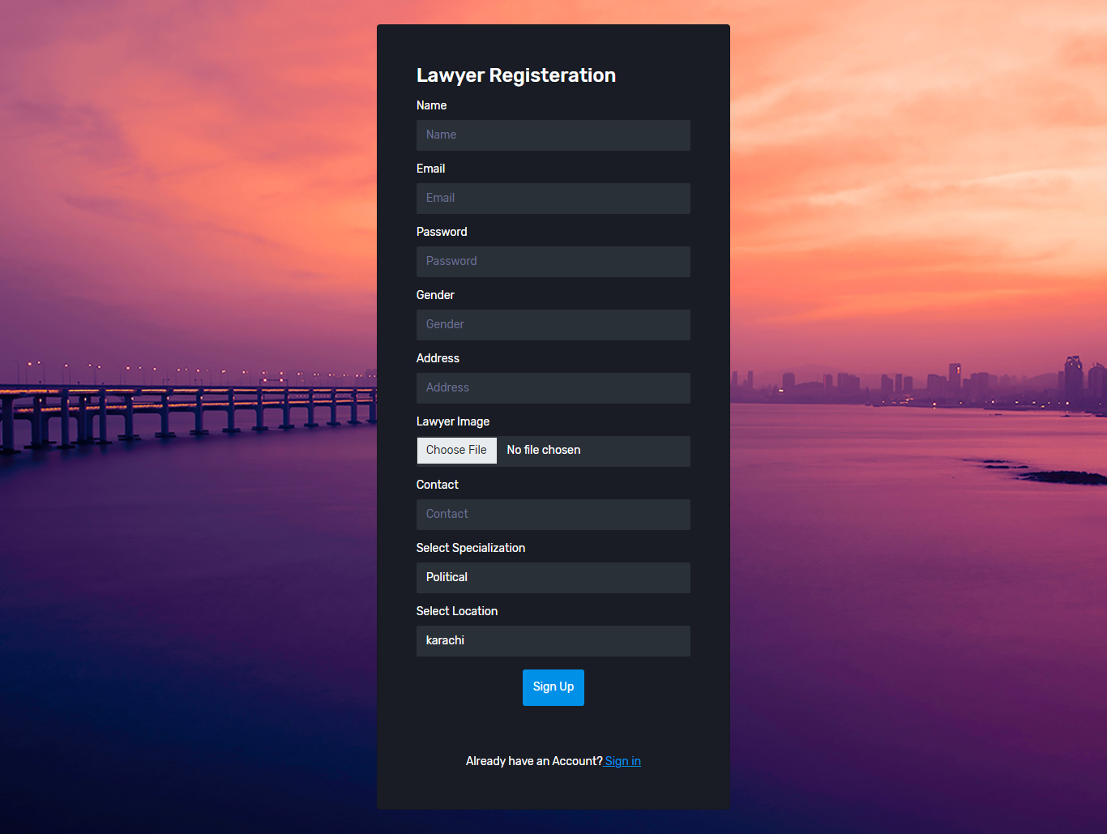

Lawyer Sign In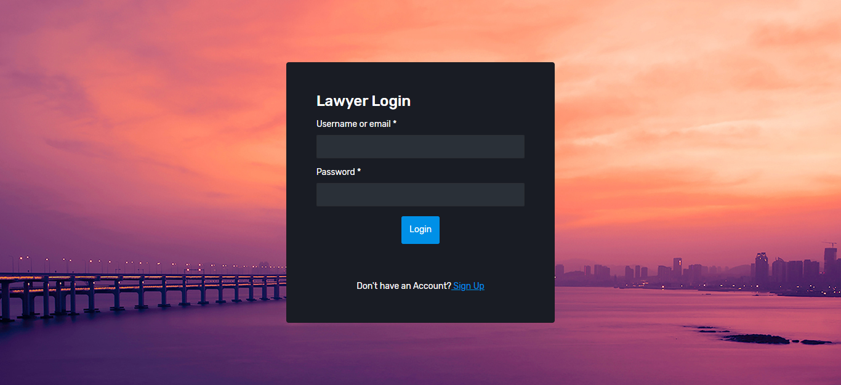

Dashboard

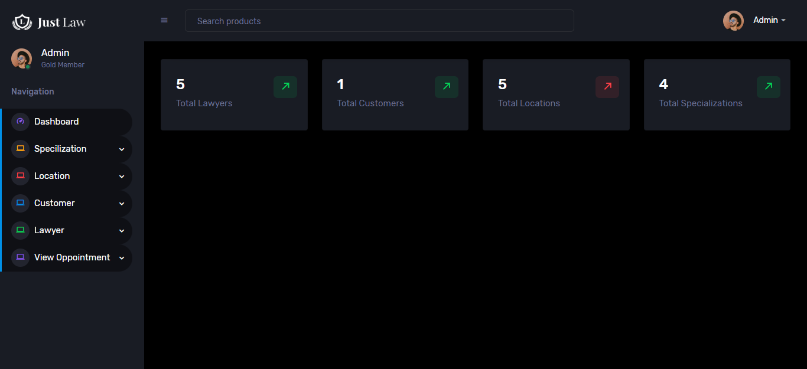

Creat And List Specialization

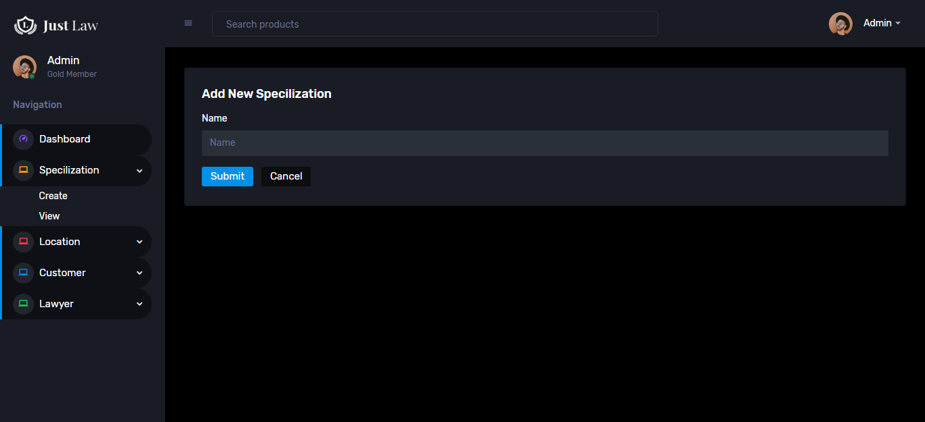

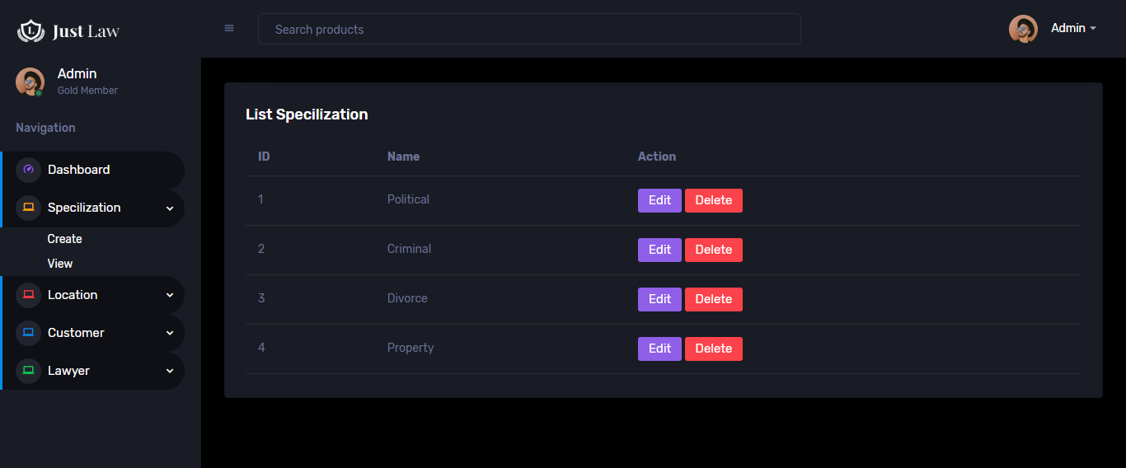

Creat And List Location

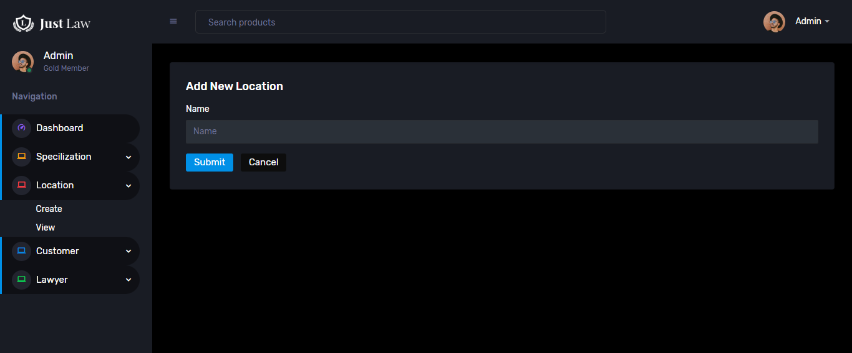

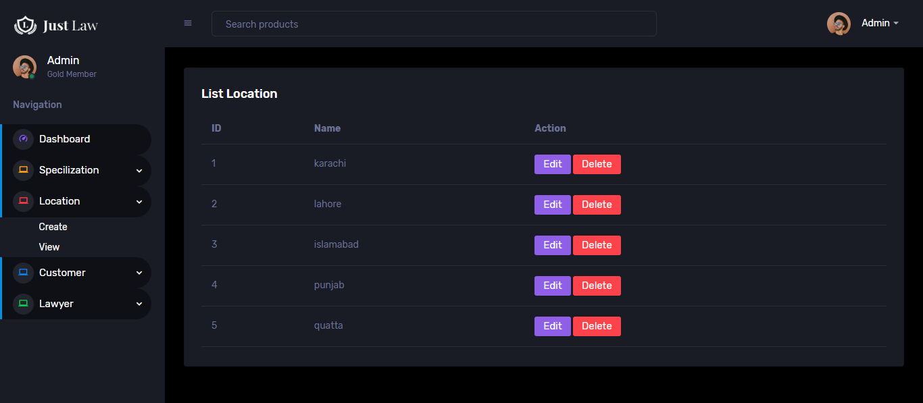

Customer List

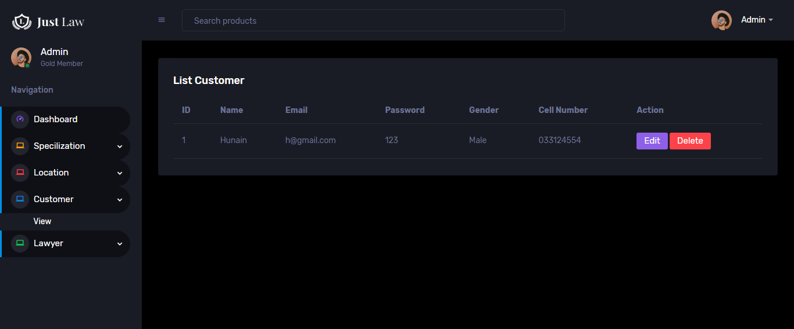

Creat And List Lawyers

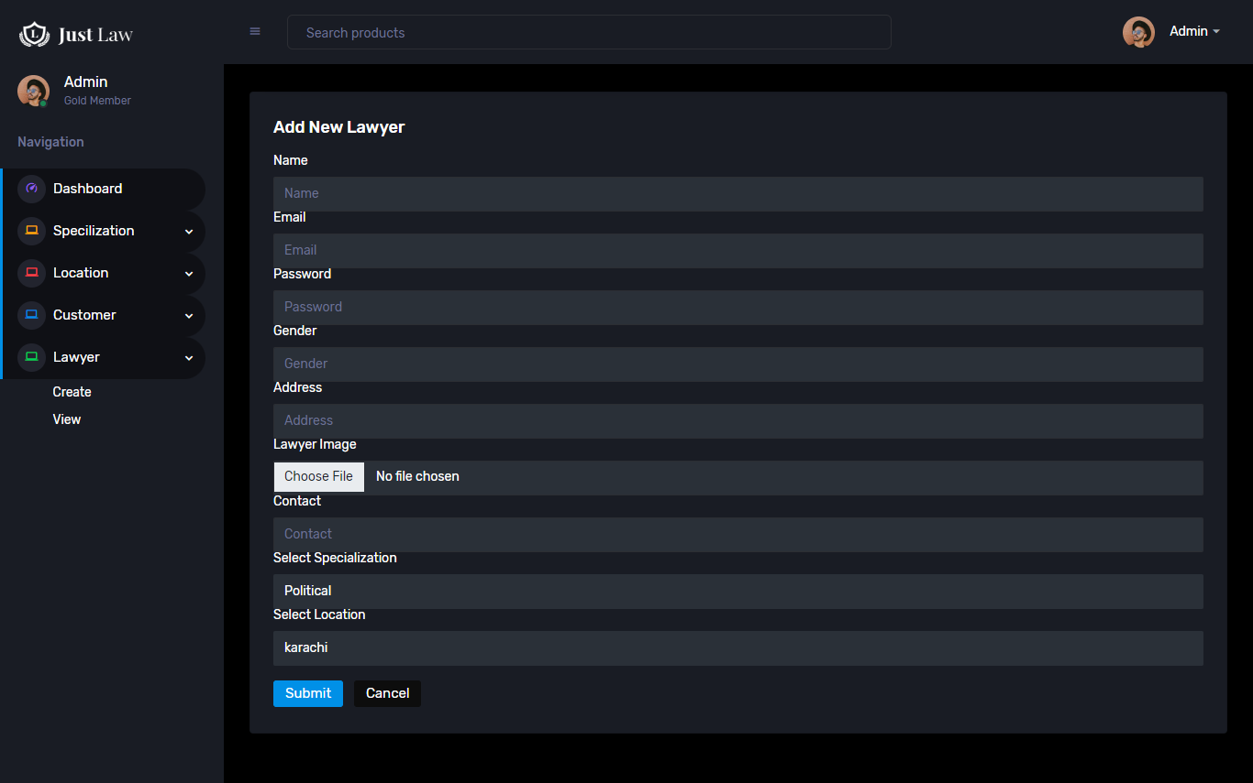

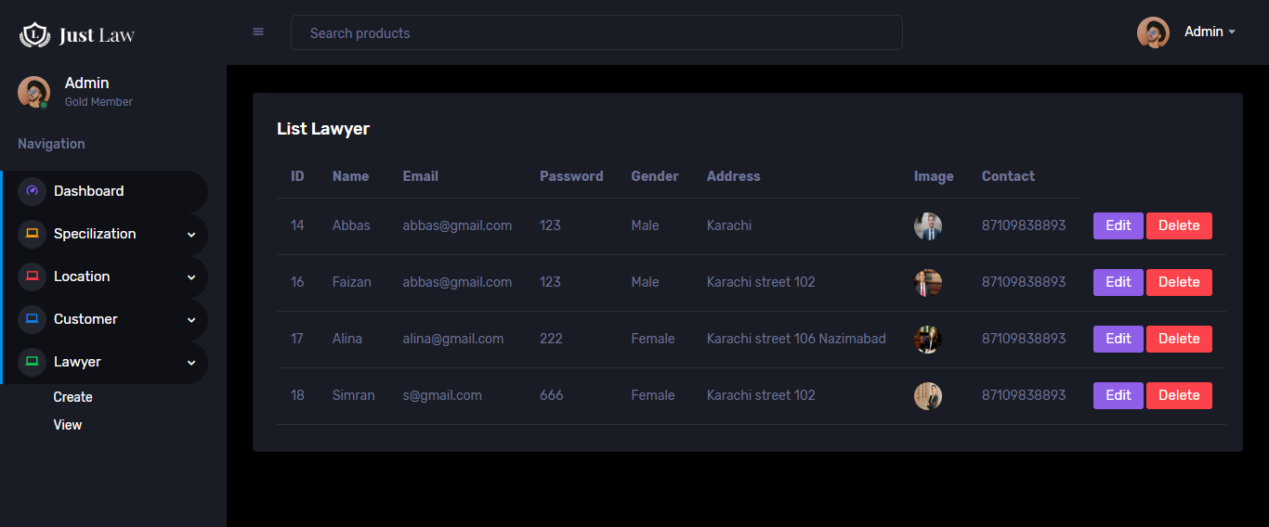

Book And List Oppointment

